NAME:Shriya Ramya Mohan EXP : 13
ROLLNO.:241901106

EXERCISE 13
DEMONSTRATE NETWORK FORENSICS USING PCAPXRAY TOOL
AIM:
To perform network forensics analysis on packet capture (PCAP) files using the PcapXray tool to visualise network traffic, identify devices, detect malicious communication, and extract important network information.
PCAPXRAY TOOL:
PcapXray is a network forensics tool that helps investigators analyze captured network traffic data (PCAP files). It takes raw packet to capture data and converts it into easy-to-understand visual diagrams and reports.

ALGORITHM:
- Install prerequisites: Python 3, Graphviz, and required libraries (Scapy, IPwhois, Netaddr, Stem, pyGraphviz, NetworkX, Pillow, Tkinter).
- Clone PcapXray repository and navigate to its folder.
- Launch PcapXray GUI using sudo python3 Source/main.py.
- Load a PCAP file via the GUI browse option.
- Start analysis by clicking “Analyze”.
- Process packets: Extract IPs, ports, and protocols using Scapy.
- Run lookups: WHOIS queries, detect Tor nodes and suspicious patterns.
- Generate visualization: Network graph with nodes (devices) and edges (communications), color-coded.
- Create and review reports: Summarize traffic, payloads, and flagged activities; export findings.
OUTPUT:
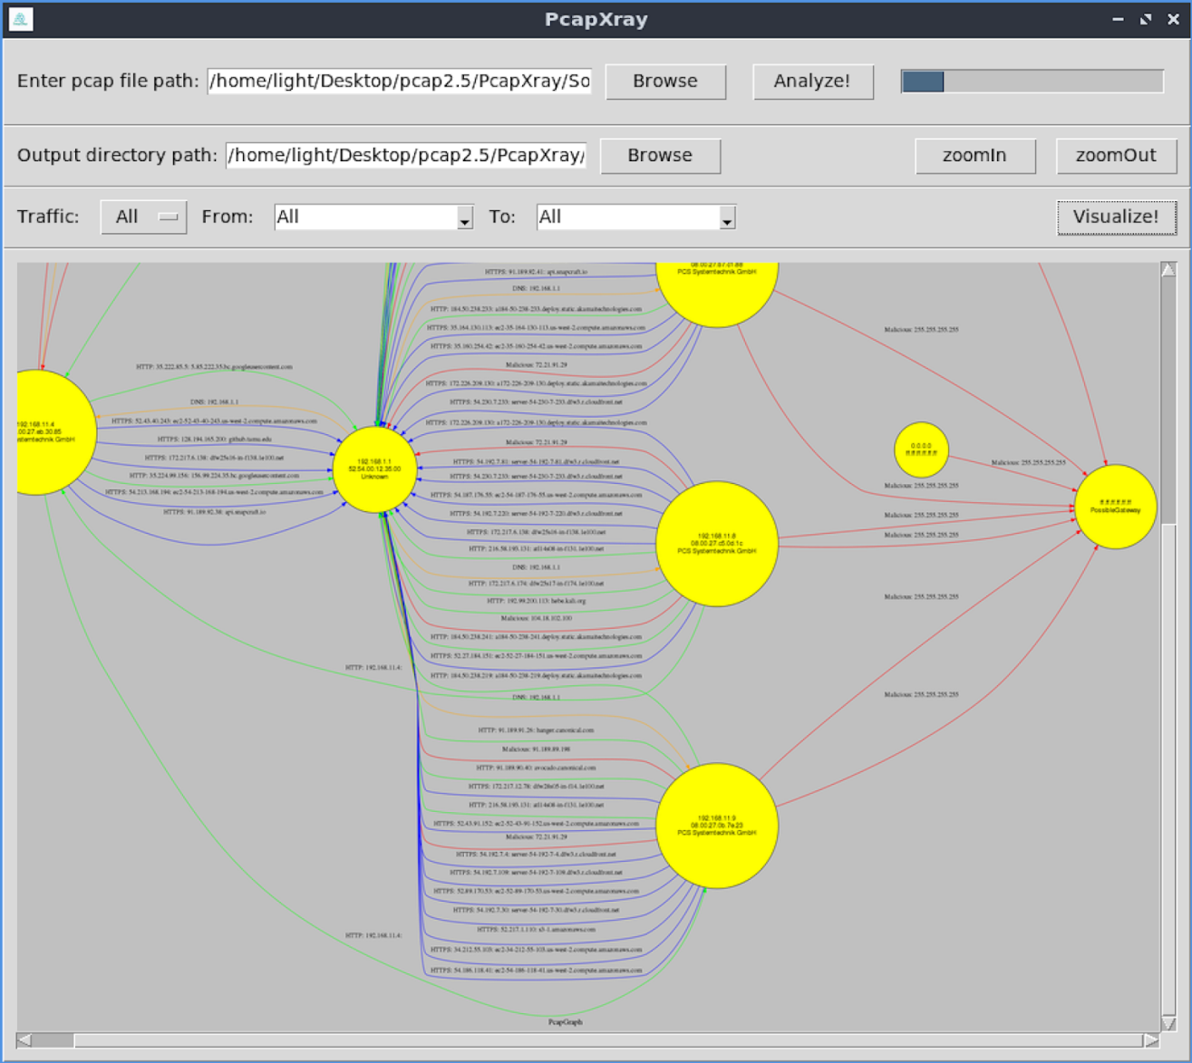PcapXray interface showing a network traffic visualization graph from a pcap file, highlighting IP addresses and potential malware communications


PACKET DETAILS: DEVICE DETAILS:
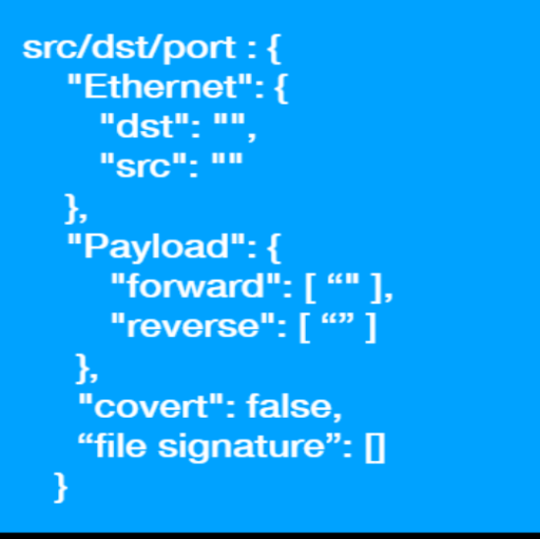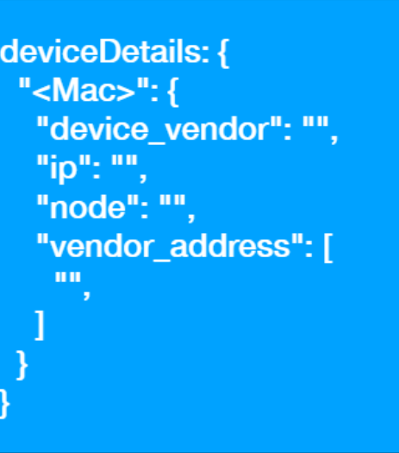

COMMUNICATION DETAILS:
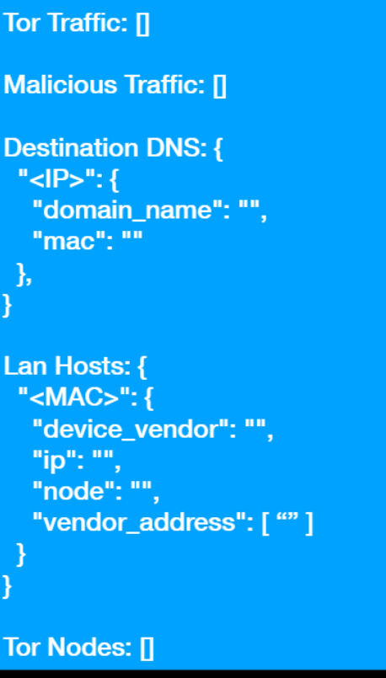

RESULT:
PcapXray quickly creates clear network diagrams from PCAP files, showing devices and suspicious traffic. It makes forensic analysis faster and easier for investigators.

